Circle of Friends
Carpooling Notes for

(Child’s Name)
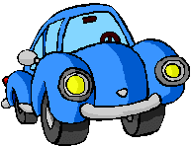
Date: _________________

Today my child will be going home with : _________________________________
(adult’s name)

Today I will ALSO be picking up _______________________________

(child’s name)

____________________________ has my permission to pick up my child from school during the 2020-2021 school year.

Parent Name ______________________________ Parent Signature _________________________________________

Circle of Friends
Carpooling Notes for

Date: _________________

Today my child will be going home with : _________________________________
(adult’s name)

Today I will ALSO be picking up _______________________________

(child’s name)

____________________________ has my permission to pick up my child from school during the 2020-2021 school year.

Parent Name _______________________________Parent Signature _________________________________________

